from
Save the Last Dance
Mandi Eizenbaum
Recipe Disclaimer

The intent of including recipes from Israel and Ukraine with this novel is a simple one: food unites communities and families with a distinct and enduring connection.
As we see in Save the Last Dance, Maya’s life in a sheltered kibbutz keeps her rooted to her cultural heritage of greater Israel through some favorite meals and her work in the kibbutz’s communal kitchen. Sophia, in Brighton Beach, New York also finds herself tethered to her Ukrainian/Jewish roots that she thought she had left behind in another world. Whether it’s a quick nosh or a 20-course holiday meal, food offers comfort, a sense of family, and a bond that stretches across cultures and groups.
After all, they say that the heart of a home can always be found in the warmth and comfort of its hearth!

With these acknowledgments in mind, please note that the novel, the publisher, the author’s website, or any other connection with Mandi Eizenbaum are in no way responsible for the outcome of any recipe found here. There are a number of factors that could possibly contribute to you not achieving the desired result when preparing any of these “passed-down” recipes from unknown sources - some of these factors can include: the ingredients, your ingredient substitutions, skipping steps, combining steps, completing steps in a different order or altering the recipe, the equipment used, my possible errors/typos,
or the reader’s individual cooking ability.

Save the Last Dance and Mandi Eizenbaum are also not claiming to be a source of nutritional or food safety advice, and readers assume full responsibility for any decisions made regarding their own health and safety.

One last note: please, don’t cook recipes with ingredients you’re allergic to, and use your best judgement with raw ingredients. You are responsible to do the necessary research and make appropriate food-handling decisions for you and for your own family.

Now, let’s get cooking!

ISRAELI AND UKRAINIAN RECIPES

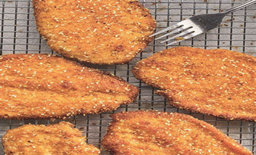
Sabich Pita Sandwich Sesame Schnitzel

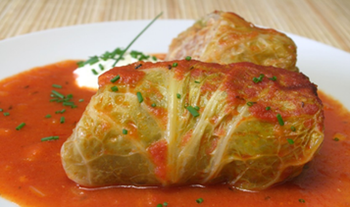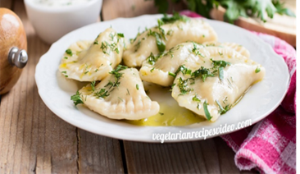
Holubtsi Cabbage Varenyky Dumplings

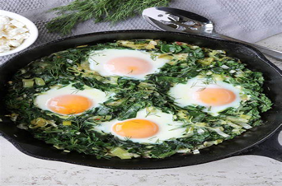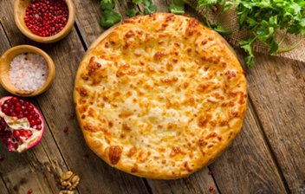
(Green) Shakshuka Khachapuri

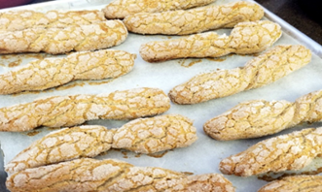 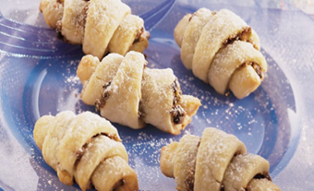 Kichel Cookies Rugelach

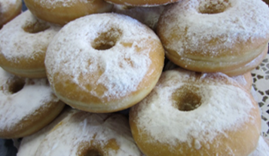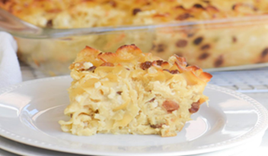
Suar Donuts (Sufganiot) Sweet Noodle Kugel
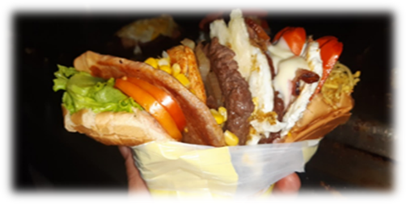
SABICH PITA SANDWICH

This hearty sandwich is reportedly most popular among Iraqi-Israelis, but we all love it! This recipe makes 2 servings.

INGREDIENTS:
1 medium Italian eggplant (about 12 to 14 ounces), peeled and cut into 1/4" inch slices
1/2 cup plus 1 teaspoon extra virgin olive oil
Kosher salt to taste
1-2 tbsp. lemon juice to taste
2 small Persian cucumbers, diced small
1 medium Roma tomato, cored, seeded, and diced small
1/4 medium red onion, diced small
1/4 cup freshly chopped parsley
1 clove garlic, grated
Serve with: Warm pita bread, hard-boiled eggs, pickles, tahini, your preferred hot sauce

INSTRUCTIONS:
Spread sliced eggplant in a single layer on a baking sheet. Brush the tops generously with olive oil. Heat a large skillet over medium heat. Working in batches, add eggplant - oil side down - in a single layer and cook, undisturbed, until charred on the bottom, about 3 to 4 minutes. Before flipping, brush tops generously with more olive oil. Flip, and cook until undersides are golden, 3 to 4 minutes more. When cooked, return eggplant to baking sheet and season with salt. In a medium bowl, whisk together lemon juice and remaining 1 tablespoon olive oil. Transfer cooked eggplant to bowl and gently toss to coat. To make tahini sauce: In a medium bowl, combine tahini, lemon juice, garlic, and ice water; whisk until smooth. Make cucumber salad: In a medium bowl, combine all ingredients for cucumber salad. Serve all in hot pita bread; add pickles, tahini, sliced eggs, salt, and hot sauce to taste.

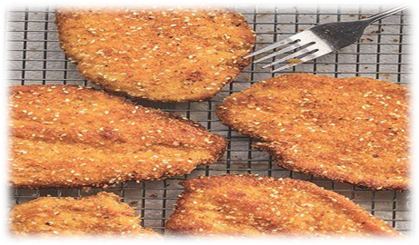
SESAME SCHNITZEL

This recipe comes from the May/June 2023 issue of Hadassah Magazine. It’s a definite winner in my book! This recipe makes 4 servings.

INGREDIENTS:
1 cup dried breadcrumbs 1/2 cup vegetable oil, for frying
1/2 cup panko breadcrumbs 4 6-oz. boneless, skinless chicken breast halves
1/4 cup sesame seeds 1/2 cup all-purpose flour
1/2 tsp paprika 2 large eggs, beaten
1/2 tsp garlic powder 1/4 tsp cayenne pepper, or more if you like it hot
1/2 tsp ground black pepper 1 tsp fine sea salt

INSTRUCTIONS:
In a shallow dish, combine the dried breadcrumbs, panko, sesame seeds, paprika, garlic powder, 1/4 tsp of the black pepper, 1/2 tsp of the salt and cayenne pepper. Place the beaten eggs in another shallow dish. In a third shallow dish, combine the flour with the remaining 1/2 tsp salt and 1/4 tsp black pepper. Season the chicken generously with salt and black pepper. Line a sheet tray with parchment. Dredge the cutlets in the flour, then the egg, then the breadcrumb mixture, shaking off the excess after each step and pressing the crumbs in firmly on both sides. Arrange them on the sheet tray as you finish the breading process. Wait 30 minutes before frying (this helps the crumbs adhere better!). In a heavy skillet, heat the vegetable oil over medium heat for 2 to 3 minutes; the oil should be hot but not smoking. Working in batches, lay 2 cutlets in the pan and fry until the underside is golden brown and crisp (2 to 3 minutes). Flip and fry for 2 to 3 more minutes. Drain on paper towels, season with salt and pepper to taste, and serve hot.

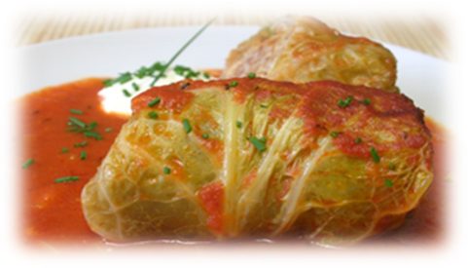
HOLUBTSI CABBAGE

Often served with sour cream as side garnish, these mild cabbage rolls are stuffed with ground beef, rice, and onions. They are sometimes referred to (in Polish) as Halupki or Golumpki.

INGREDIENTS:
1 large head of cabbage 6 oz can tomato paste
3/4 lb ground beef 2 Tbsp vegetable oil
1 cup ground carrots 2 tsp sea salt
1 med yellow onion, diced 1-1/2 tsp paprika
1/3 cup parsley or dill, chopped 1 tsp black pepper
2 cloves minced garlic 1 cup rice
1 large egg 2 tsp sugar

INSTRUCTIONS:
Core and boil cabbage in a big pot. Once water boils, simmer until leaves can easily be pulled off. The color of the leaves will get brighter. In a large bowl, mix the meat, carrots, onion, parsley, garlic, egg, oil, 1/3 can tomato paste, salt, pepper, and paprika. Add cooked rice to mixture. Cool the cabbage leaves and slice out the hard stems of the leaves without ripping the leaf. Line the bottom of a large pot with the stems so that the cabbage rolls do not stick to the bottom of the pot. Spoon a dollop of the meat/rice mixture and in the middle of a cabbage leaf and roll tightly. Place the stuffed leaf (seam down) in the pot, on top of the layer of stems. You can layer the stuffed cabbage leaves on top of each other as needed. Now, preheat oven to 325 degrees. Add water, oil, and 2/3 can tomato paste to a small saucepan and season to taste with salt and sugar. Pour the sauce over the stuffed cabbage in the large pot and bake for one hour.

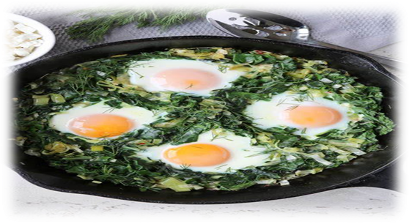
(GREEN) SHAKSHUKA

This recipe comes from the May/June 2023 edition of the Hadassah Magazine. It is a bit different from the more common RED shakshuka (prepared in a tomato base). This recipe makes 4 to 6 servings.

INGREDIENTS
1/3 cup extra virgin olive oil 1 large onion, finely diced
3 large garlic cloves, thinly sliced 1/4 cup vegetable broth
1 cup mixed fresh herbs (parsley, 1 tsp chopped fresh thyme, za’atar or oregano
Cilantro, basil) finely chopped 1 Tbsp finely chopped jalapeños
1 tsp kosher salt 1/4 tsp freshly ground black pepper
1/8 tsp freshly grated nutmeg 1/2 cup half-and-half
8 large eggs 1 pound (about 16 cups) roughly chopped
stemmed mixed green leaves
(i.e., kale, spinach, chard)

INSTRUCTIONS:
Set a rack in the top third of the oven. In a 12-inch oven-safe skillet, heat the olive oil over medium heat. Add the onions and cook, stirring until lightly golden, 9-10 minutes. Add the garlic, stirring 1 more minute. Raise the heat to medium-high and add the greens in batches, stirring as they wilt – about 2-3 minutes. Add the vegetable broth and cook until mostly absorbed. Stir in the mixed herbs, thyme, jalapeño, salt, pepper, and nutmeg. Next, preheat the broiler. Reduce the heat on the stove to medium-low, stir in the half-and-half, and simmer until mixture unifies and thickens slightly, 1-2 minutes. Use a spoon to hollow out eight small wells for the eggs and crack the eggs into the wells. Cook for 3 minutes, then transfer to the oven and cook until the whites are just opaque, but the yolks are still runny, 2-3 minutes.

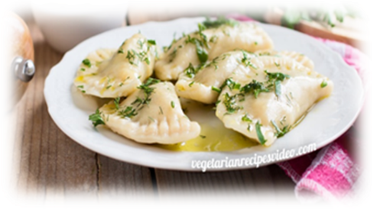
VARENYKY DUMPLINGS

Ukrainian dumplings are usually made with potato and onion filling and served with sour cream. This recipe makes 35-40 dumplings.

INGREDIENTS:
1 cup warm water 1/2 tsp black pepper
2 cups all-purpose flour 1/3 tsp salt for filling
1/2 tsp salt for dough 1 yellow onion
5 large potatoes, peeled
2 Tbsp butter

INSTRUCTIONS:
Pour warm water into a deep mixing bowl. Add flour and salt. Knead the dough first with a spoon and then with your hands until it is soft and a little sticky. Cover with plastic wrap and let sit for 30 minutes. Cut and peel potatoes into small cubes. In a saucepan, boil potatoes until soft (drain water). Next, in a frying pan, fry onion (chopped) in butter until brown. Mash the boiled potatoes, add the onions, salt and pepper to taste. To make a creamier consistency to the potatoes, you can add warm water to the mixture. Sprinkle counter with flour and spread the dough mixture on the flour. It may be easier to use half the dough at a time. Roll out until very thin and, using a glass or cup, cut circles about 3 inches in diameter. Place a dollop of the potato mixture near the edge of each dough circle, and then fold the dough over and pinch the edges closed with your fingers or a fork. Now, bring water to a boil in a large pot (add a pinch of salt to the water). Drop the dumplings into the water and wait for them to float to the top. Boil for 2 more minutes. Transfer the boiled dumplings to a bowl and coat with light layer of butter so they don’t stick together. Sprinkle with chopped herbs, to taste. They can be served with sour cream, ketchup, or your favorite savory sauce.

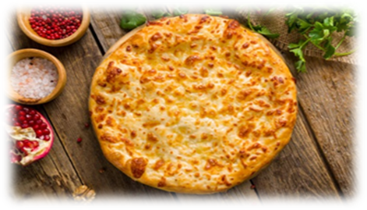
KHACHAPURI

Khachapuri is a crispy, thin bread filled with soft, tender cheese. This recipe for Imeruli Khachapuri (Georgian Cheese Bread) is found in The Bucholtz Family Cookbook, one of the cookbooks created at FamilyCookbookProject.com.

INGREDIENTS:
Filling:
1 cup mozzarella cheese 1/2 tsp salt, if needed
1 cup farmer cheese 1/2 tsp fresh ground pepper
1 cup goat cheese 1 tsp paprika
1 cup feta cheese 2 large eggs

Add or substitute any other cheeses, to your liking. Also, you can add spinach to this filling.

Dough:
Two packages Phyllo dough or Canadian pastry dough, defrosted

INSTRUCTIONS:
Preheat oven to 395º. Butter a large baking sheet. On a floured surface, roll out one package of dough to cover baking sheet. Cover with filling (all ingredients mixed together thoroughly). Put another layer of dough on top. Fold/pinch together sides and corners. Paint top with beaten egg and prick a few times with fork. Bake for 40 minutes or until is brown.

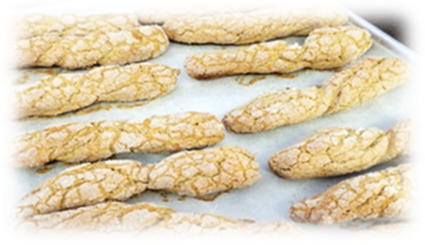
KICHEL (BOW-TIE) COOKIES

Kichel is a light, airy, crunchy cookie, and it is usually coated in sugar. The dough is very simple and savory; the sweetness comes from the sugar coating. They do not have to look like bow-ties (like my grandmother used to make) . . . sometimes they are simply flat discs or stick-like strips (like I make). This recipe makes 3 dozen cookies.

INGREDIENTS:
6 eggs 2 Tbsp sugar
1 cup oil 1 Tbsp cinnamon
1-3/4 cups flour ½ cup sugar

INSTRUCTIONS:
Preheat oven to 300 degrees. Combine all ingredients except cinnamon and sugar together in a large bowl. With an electric mixer, mix at medium speed for 20 minutes. Make balls (teaspoon-size) of the dough and twist into bowtie shapes. Place each on ungreased cookie sheet about 2 inches apart. Combine cinnamon and sugar and sprinkle liberally over cookies.
Bake for 30-40 minutes until the edges and bottoms are deep golden brown. Allow to cool completely, leaving them out at room temperature for several hours. (For puffier Kichel, bake on the bottom third of the oven. Kichel will stay fresh for at least several days stored in an airtight container. They also freeze very well.)

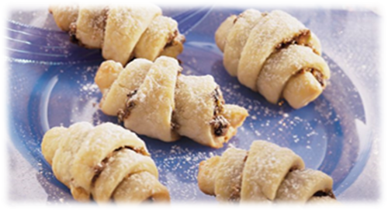
RUGELACH

These delicious pastries may look difficult to assemble, but the dough is really quite simple to make. A good suggestion is to begin this recipe the day before in order to allow the dough to rest overnight. This recipe makes approximately 32- 48 serving(s).

INGREDIENTS
For the Dough:
1 package dry yeast 3 Tbsp sugar
¼ cup lukewarm water 3 cups flour
1 cup margarine 2 eggs

Preserve Filling: Alternate Fillings:
1 cup raspberry or apricot preserves 1-½ cups ground walnuts
¾ cup cinnamon OR 1 Tbsp cinnamon and 1 cup sugar
¾ cup sugar OR 1 cup sugar and ½ cup cocoa

INSTRUCTIONS:
In a small bowl, dissolve yeast in warm water and let stand until bubbly. In a saucepan, melt margarine. In a separate bowl, beat eggs, Stir in flour and sugar. Add melted margarine and yeast and mix until dough is formed. Cover bowl and refrigerate overnight. The next day, preheat oven to 350 degrees and prepare your favorite filling by mixing together the ingredients for each. Divide dough into 4 equal parts and roll out each part into equal circles on a floured board. Lightly brush each circle with oil and spread filling mixture, leaving a 1/2- inch margin around the outer edge of the circle. Cut each circle into triangle pieces (approximately 8-12 per circle), like a pizza pie. Roll each triangle from outer edge to the point in the middle of the pie, Place each roll 1 inch apart on greased cookie sheet. Bake until slightly browned, approximately 35-45 minutes.

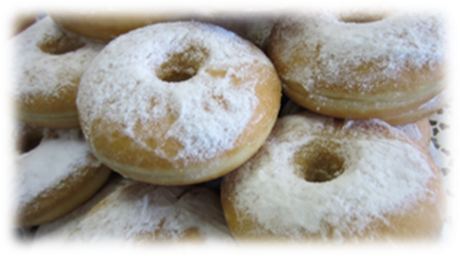
SUGAR DONUTS (SUFGANIOT)

Doughnuts are an old-fashioned treat, most traditionally eaten on Hanukkah because they are fried in oil. This recipe makes 4 dozen doughnuts.

INGREDIENTS:
2 oz fresh yeast 3 Tbsp margarine
¼ cup warm water 1 Tbsp oil
2 tsp sugar 4-1/4 cups flour
1 egg 1/3 cup sugar
½ cup water oil for frying
½ cup orange juice confectioners’ sugar
pinch salt

INSTRUCTIONS:
In a large bowl, dissolve yeast in water and sugar. Allow to stand for several minutes until bubbly. Add remaining ingredients and knead until smooth, about 15 to 20 minutes. Cover dough and allow to rise until doubled in bulk – about 1 hour.
Roll out dough, ½-inch thick on a floured surface. Cut into circles with a doughnut cutter or a glass. Allow to rise again until doubled in bulk – about 30 minutes.
Heat 3 to 4 inches of oil in a 4-quart pot until hot. Deep-fry doughnuts in hot oil with cover on pot (it makes doughnuts expand). When golden brown, remove cover, turn doughnuts over, and brown on second side. Remove with slotted spoon and drain on paper towels. When cooled, sprinkle with confectioners’ sugar.

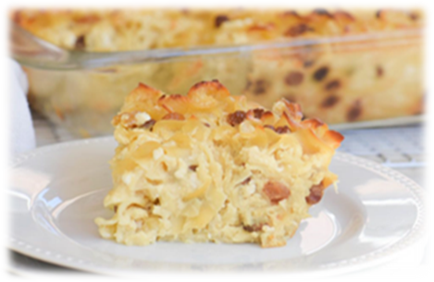
SWEET NOODLE KUGEL

Over the years, I have found dozens of recipes for kugel – but this one is the best yet! This recipe makes 9 to 12 servings.

PUDDING INGREDIENTS:
1 (16 oz) package of wide egg noodles 1 cup milk
4 eggs, beaten ½ cup butter, melted
½ cup sugar ½ cup raisins (or cherries, drained)
1 pound cottage cheese
1-pint sour cream

TOPPING INGREDIENTS:
1 cup crushed corn flakes
1 tsp cinnamon
¼ cup brown sugar

INSTRUCTIONS:
Preheat oven to 350 degrees. In a 4-quart pot, boil noodles (with a bit of salt) for 10 minutes. Drain and rinse with cold water. Then, in a large bowl, mix all pudding ingredients with noodles and pour into a greased 9x13-inch baking pan. For topping: mix the topping ingredients in a separate bowl and sprinkle on top of the noodle/pudding. Bake for approximately 1 hour or until top is brown.

